**І рівень**

1. **В Google docs створи 5 тест-кейсів для функціонального тестування сайту** [**https://automoto.ua/uk/**](https://automoto.ua/uk/) **(5 найбільш пріоритетних тестів).**

**1**

| **Test Case ID** | AUTO_01 | **Test Case Description** | Test the login with valid data to AUTOMOTO |
| --- | --- | --- | --- |
| **Created By** | Anush Shaboian | **Version** | 1.0 |
| **Test Data Requirement** | Login can be a phone number (10 digits). | | |
| **Priority** | 1 | | |

| **Step №** | **Step Details** | **Expected Results** |
| --- | --- | --- |
| 1. | Navigate to enter. | Site should open. |
| 2. | Enter valid phone number data. | Credential can be entered. |
| 3. | Click Submit. | Customer is logged in. |

**2**

| **Test Case ID** | AUTO_02 | **Test Case Description** | Test get a list using the Search form to AUTOMOTO |
| --- | --- | --- | --- |
| **Created By** | Anush Shaboian | **Version** | 1.0 |
| **Test Data Requirement** | In input fields “price from” and “price to” entered digits in positive value. | | |
| **Priority** | 1 | | |

| **Step №** | **Step Details** | **Expected Results** |
| --- | --- | --- |
| 1. | Navigate the search form. | The Search form is available on the main page. |
| 2. | Select one of the car states. | The state of the machine is selected. |
| 3. | In dropdown lists select any variant. | Variants are selected. |
| 4. | In the input field “Price from” and “Price to” enter valid data. | The input field is entered. |
| 5. | Click on the button “Search”. | The list of cars opens according to the selected parameters. |

**3**

| **Test Case ID** | AUTO_03 | **Test Case Description** | Test get a list using the "Advanced search" form to AUTOMOTO |
| --- | --- | --- | --- |
| **Created By** | Anush Shaboian | **Version** | 1.0 |
| **Test Data Requirement** | Enter positive values (digits) in the fields where you can write digits. | | |
| **Priority** | 1 | | |

| **Step №** | **Step Details** | **Expected Results** |
| --- | --- | --- |
| 1. | Click on the “Advanced search” form on the main page. | The “Advanced search” form is opened. |
| 2. | In dropdown lists select any variant. | Variants are selected. |
| 3. | In the input fields enter positive values. | Credentials can be entered. |
| 4. | In section with radio batton and checkbox select any variant. | Variants are selected. |
| 5. | Click on the button “Show”. | The list of cars opens according to the selected parameters. |

**4**

| **Test Case ID** | AUTO_04 | **Test Case Description** | Test the adding an ad to AUTOMOTO |
| --- | --- | --- | --- |
| **Created By** | Anush Shaboian | **Version** | 1.0 |
| **Test Data Requirement** | You can add only 1 link with add in the input field. | | |
| **Priority** | 1 | | |

| **Step №** | **Step Details** | **Expected Results** |
| --- | --- | --- |
| 1. | Navigate to the “My add” page. | Page “My add” is open. |
| 2. | Enter a valid link in the input field. | A valid link is entered. |
| 3. | Click Add. | Ad is added to the “My add”. |

**5**

| **Test Case ID** | AUTO_04 | **Test Case Description** | Test viewing photos and information in an ad. |
| --- | --- | --- | --- |
| **Created By** | Anush Shaboian | **Version** | 1.0 |
| **Test Data Requirement** |  | | |
| **Prority** | 1 | | |

| **Step №** | **Step Details** | **Expected Results** |
| --- | --- | --- |
| 1. | Navigate an ad on the site. | The ad is open. |
| 2. | Click on the photo and view it. | The photos opened. |
| 3. | Scroll the page and see the information about car. | The page is scrolling and there is information about car. |

**2. За допомогою** [**https://reqbin.com/**](https://reqbin.com/) **протестуй****наступні методи API** [**Reqres**](https://reqres.in/)**:**

* **LIST USERS**
* **SINGLE USER**
* **CREATE**
* **UPDATE (PUT)**
* **UPDATE (PATCH)**
* **DELETE**
* **REGISTER - SUCCESSFUL**
* **LOGIN - SUCCESSFUL**

**LIST USERS (GET)**

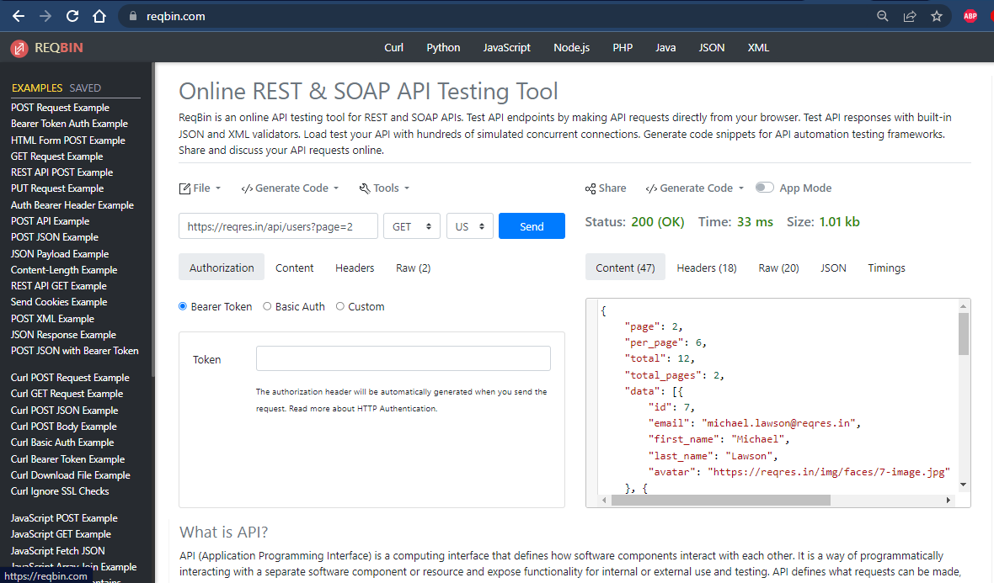

**SINGLE USER (GET)**

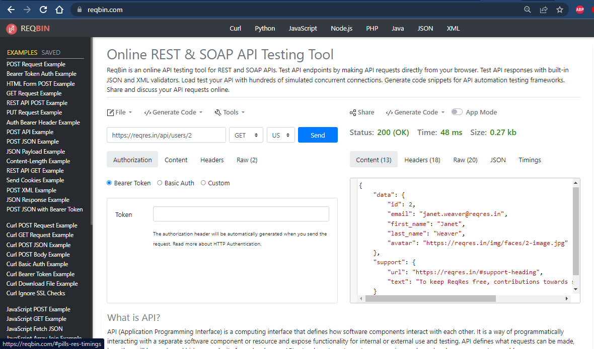

**СREATE (POST)**

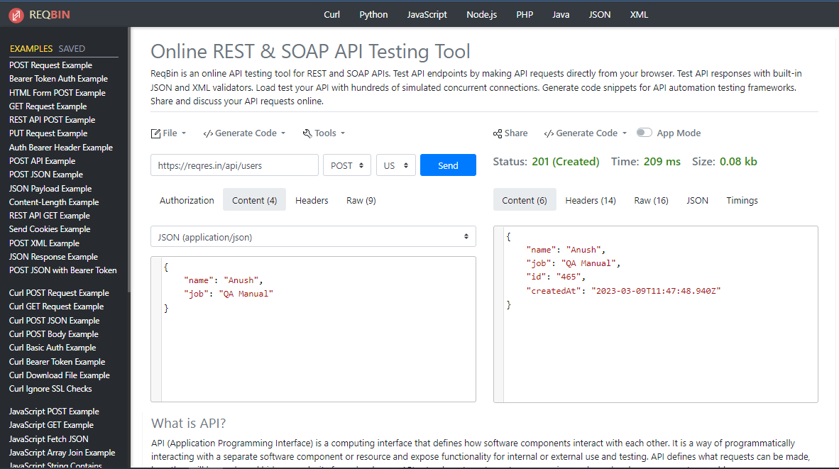

**UPDATE (PUT)**

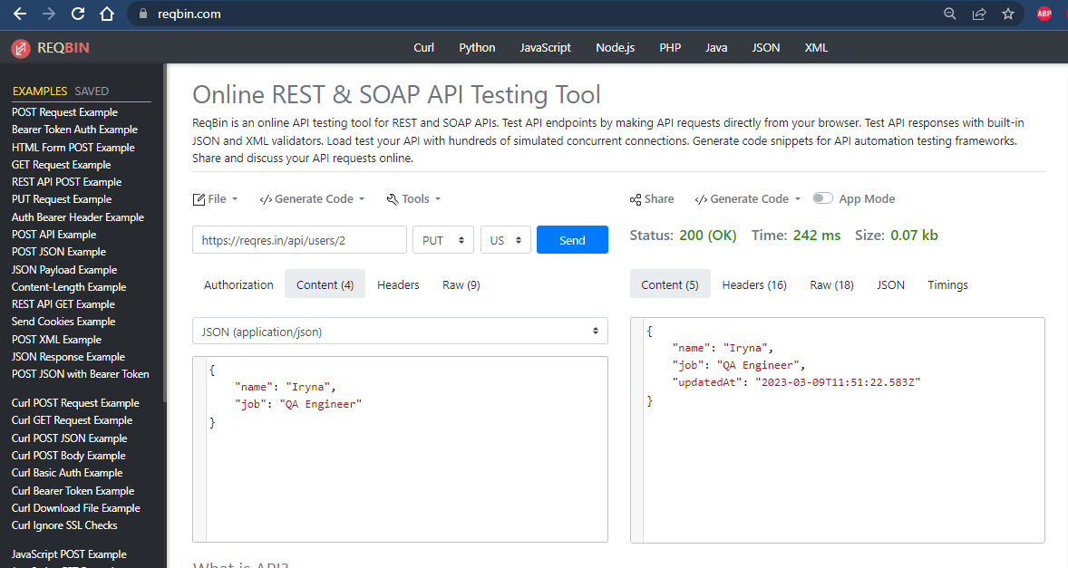

**UPDATE (PATCH)**

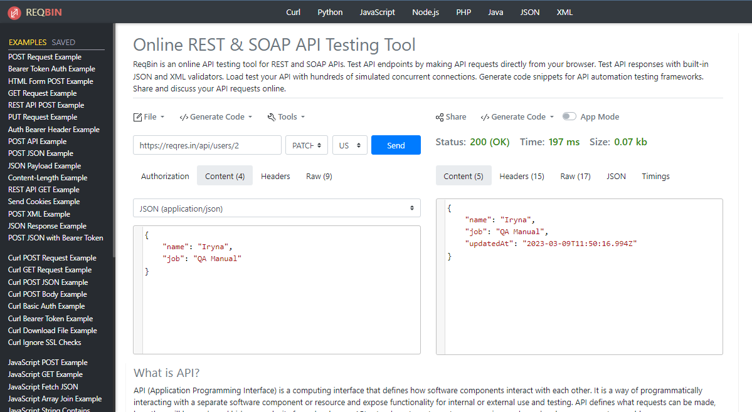

**DELETE**

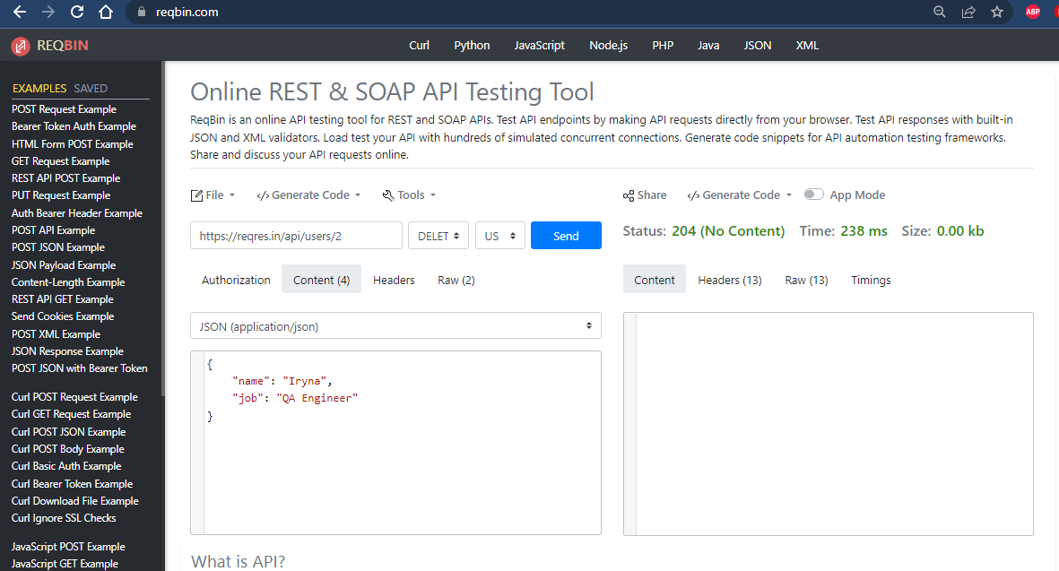

**REGISTER - SUCCESSFUL (POST)**

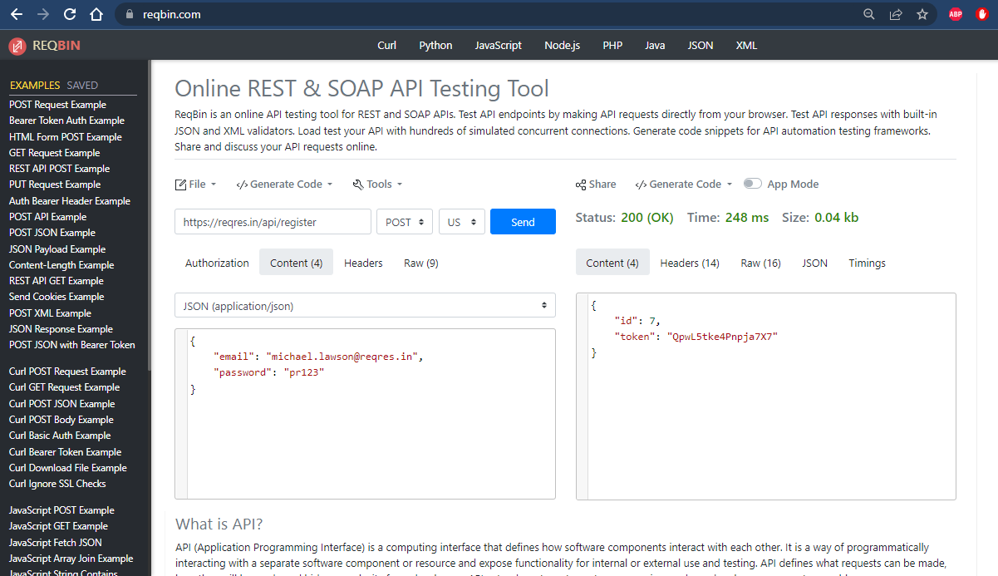

**LOGIN - SUCCESSFUL (POST)**

